***COAL Lab02 Submission***

***Name: Yash Raj***

***Roll Number: 24k-0737***

***Task#1:***

1. After executing add eax, 20, the value in the **EAX register will be 30**.
2. ***Before State:***

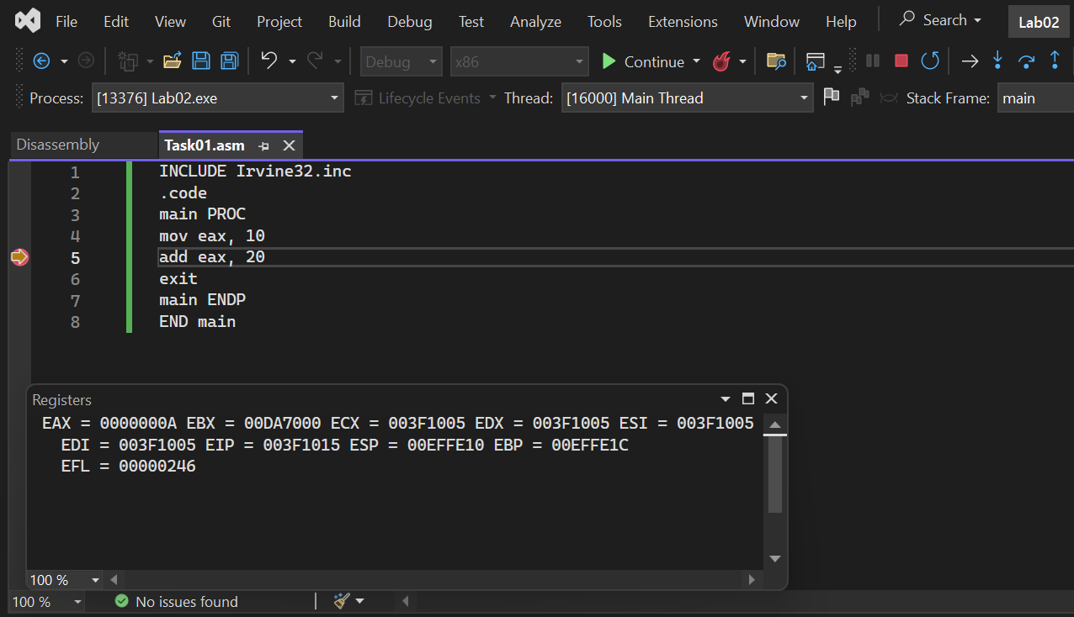

1. ***After State:***

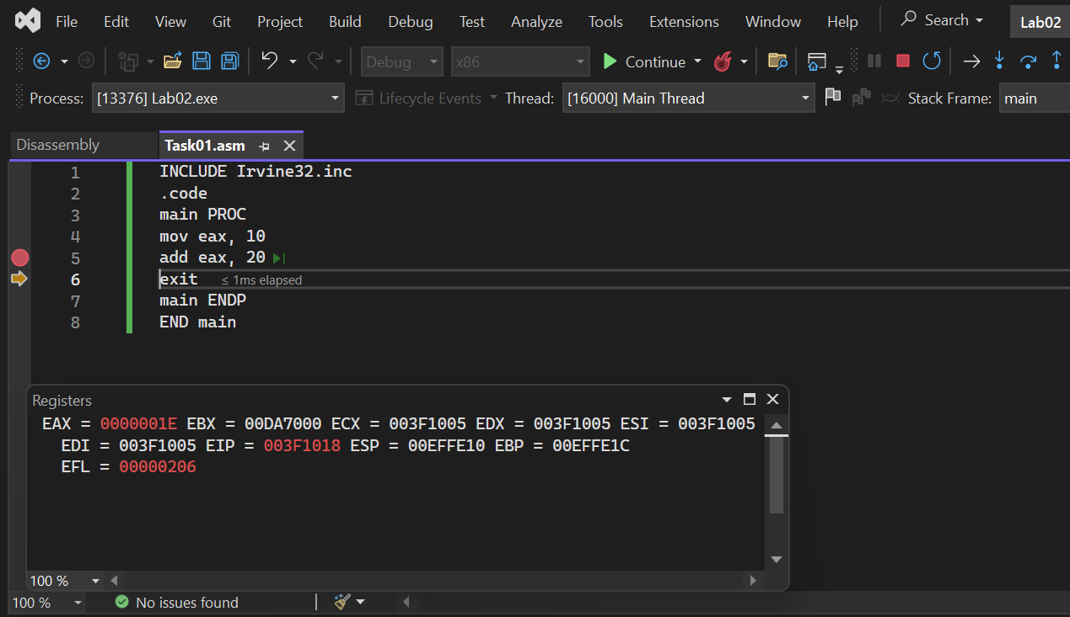

***Task#2:***

***Code:***

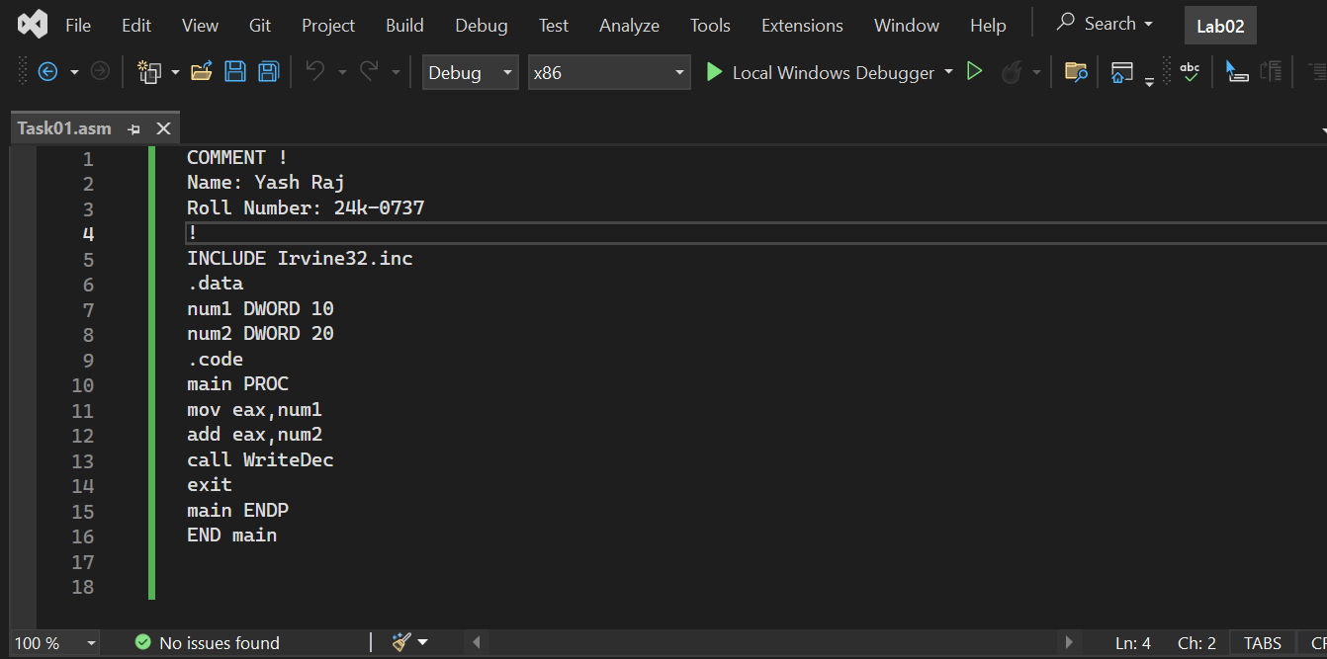

***Output:***

